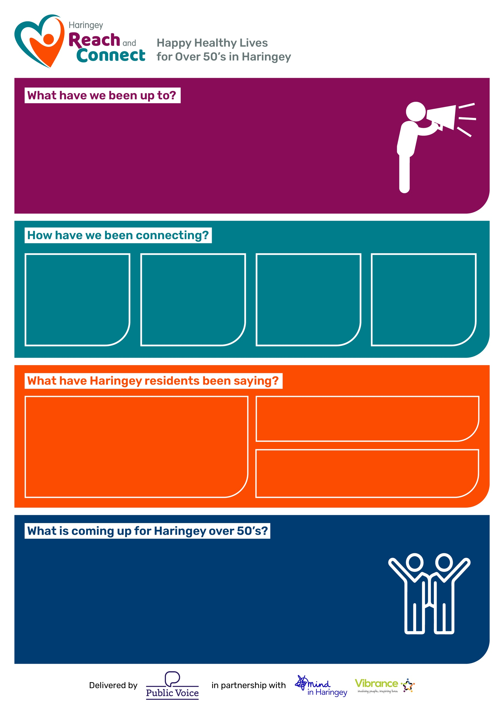
“What I was surprised by was that many older people do not have significant contact with the younger age group.”
"What a well organised event, stimulating and at times moving. So many people put a huge effort into making the day the success that it was. We, the guests, owe them our thanks. The warmth of the welcome was much appreciated, and the generous hospitality was exceptional”
- Look out for Haringey’s Age Well Festival 2025 to be held on Saturday 20th September 2025 at Bruce Castle Park.
- Get involved in preparation for the Purple Parade, look out for our workshops to create banners, flags and glitzy outfits to show case and celebrate older residents and the amazing groups that bring our community together and support older residents to Age Well.
- Find out about Take 5 to Age Well actions we can all do ‘Connect, Learn, Eat, Drink & Move’.
“Thank you for being very helpful and kind and of great benefit. Really looking forward to your next visit."
1305

Connections
with Haringey
Over 50’s
Residents

116

Workshop Participants
47

Groups
facilitated and
outreach
activities
229

1-1 Brief
Intervention
referrals

- Age Well Festival (AWF) 2025 launch at Alexandra Palace with over 100 attendees, displaying photographs and artwork from AWF 2024.
- Mental Health week presentation to DWP Midlife MOT initiative.
- Artful Codgers creative wellbeing group delivered 8 workshops
- ‘Age Without Limits’ event with Sewn Together and The Together Project hosting intergenerational activities at Haringey Sixth Form
- Loneliness Awareness Week activities and training for VCS
April to
June 2025

