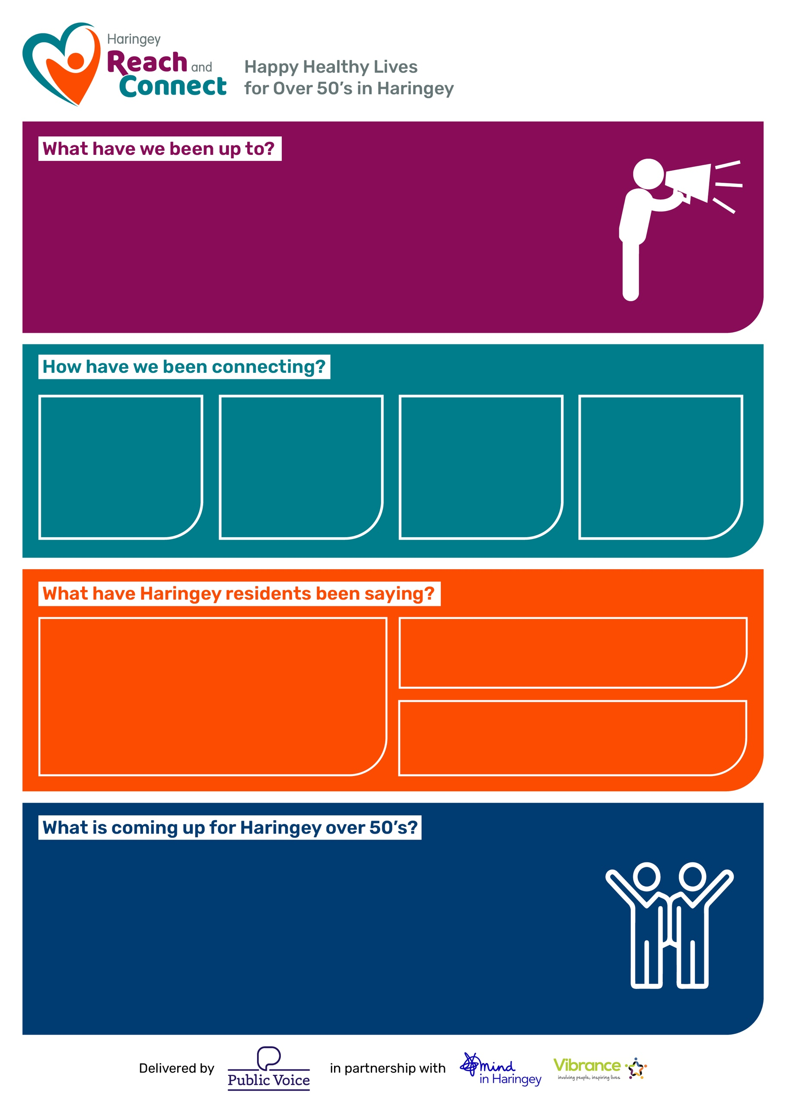
“I really appreciate every effort you are making to make sure that all goes well for me.”
“A marvellous festival, several people thought it was bigger and better than last year. Thanks a million, to you and all the others who helped to organise things”

“My mum felt very seen and appreciated. She really enjoyed the diversity of the event.”
- Winter Wellness advice and information
- Developments in support for later life planning, dying matters and grief support events
- Age Well Festival impact report and next steps exploring what it takes to become an Age Friendly Borough
- Artful Codgers monthly group now available until March 2026
- Quarterly update to Reach and Connects Local Activities Guide
- Continuation and growth of the Conversation Café Network
“Thank you very much for all of your help, throughout a very difficult time that I was going through.”
2204

Connections
with Haringey
Over 50’s
Residents

471

Workshop Participants
42

Groups
facilitated and
outreach
activities
226

1-1 Brief
Intervention
referrals

- Purple Parade creative workshops in collaboration with a working group of residents and local VCS leading up to the big parade with over 100 participants on the day at this year’s Age Well Festival 25. Groups worked with included Explorers Men's Club, Cypriot Centre, Moselle Community Project and more, such as the ‘Braid for the Parade’ event with Sewn Together.
- Facilitation of the Connect Zone and support for the Guest/VIP Zone with OldAlone UK at the AWF 25.

July to
September 2025

